Hands-On Exercises
1. Web Design Evaluation.
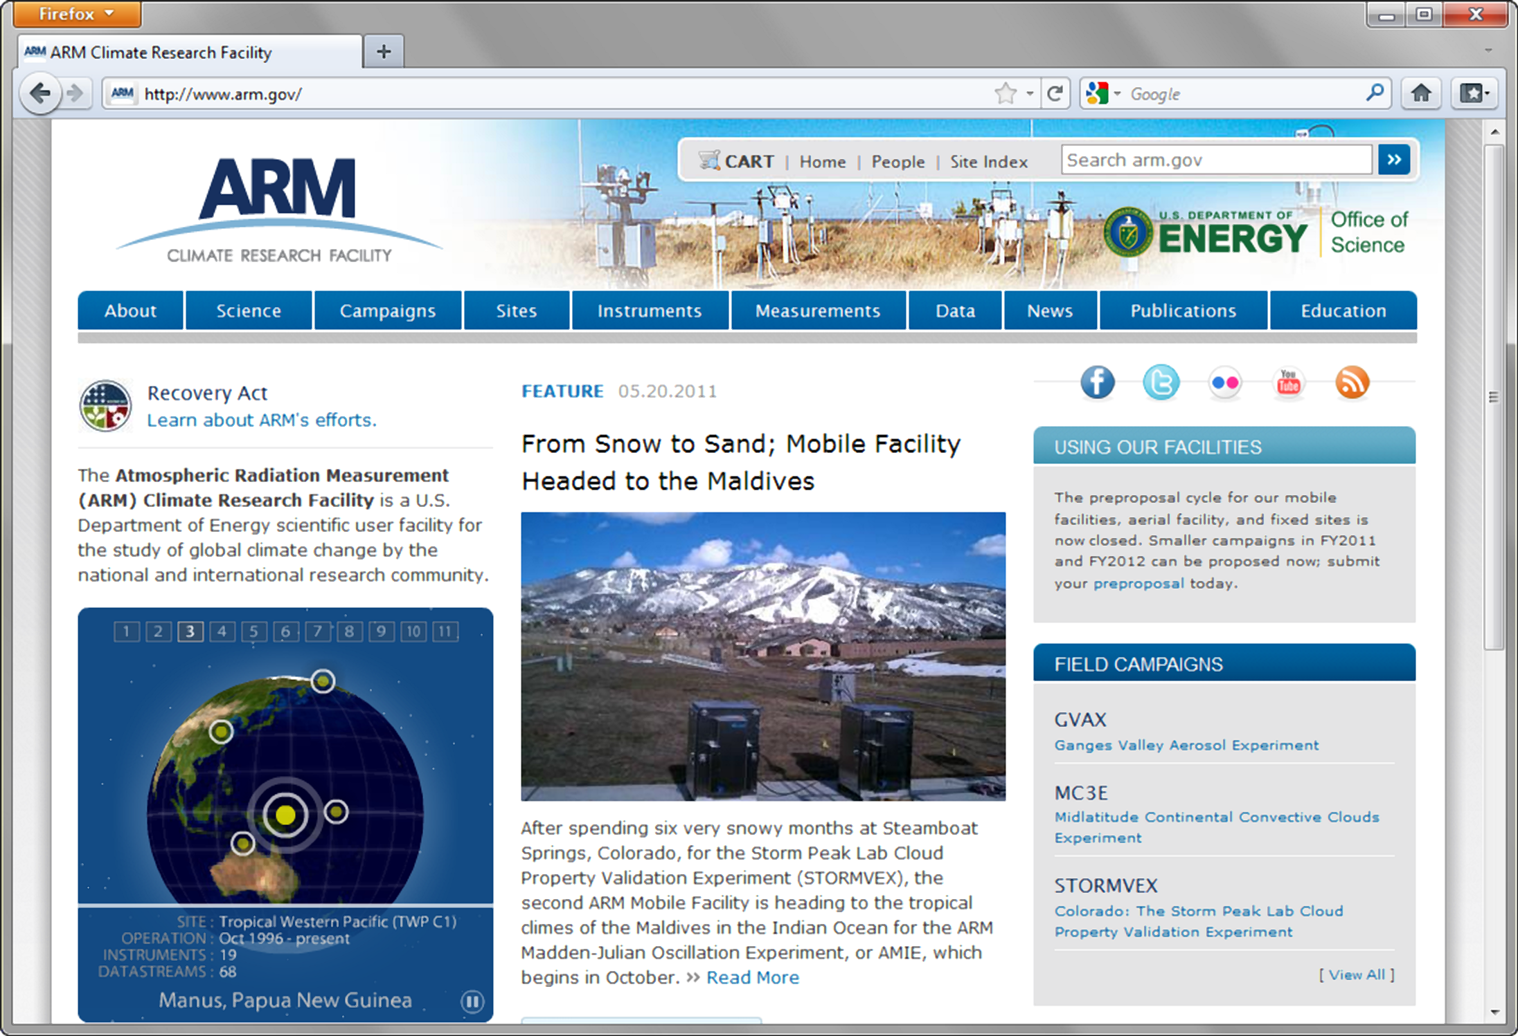
Student answers will vary. Here’s an example for http://www.arm.gov.
Indicate the type(s) of navigation evident. Horizontal main navigation, site search, and site index
Describe how the design principles of contrast, repetition, alignment, and proximity are applied. Be specific.
Contrast: High level of contrast between text and background in all page elements as is typical when a white background is used.
Repetition: The blue color from the logo is repeated in other page elements, such as the motto area and section headings. The thumbnail images (along with their headings and text) in the right sidebar demonstrate effective use of repetition. Alignment: The page demonstrates effective vertical and horizontal alignment.
Proximity: The navigation links are grouped together under the logo area. “Housekeeping-type” links (cart, search, etc. are grouped together in the upper right corner.
Suggested improvements. The very small text gray text on the gray background in the right hand column has poor contrast. Either darken the text or lighten the background (or both) to achieve sufficient contrast. Use http://webaim.org/resources/contrastchecker/ as a tool for color selection with sufficient contrast between text and background.
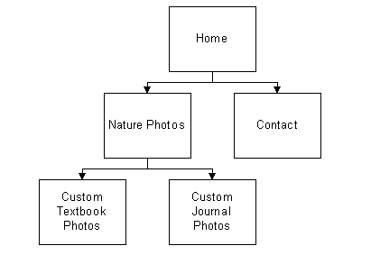
2. Practice with site maps.
a. Doug Kowalski, Nature Photographer
Student answers will vary. The site map at the left is a suggested solution.

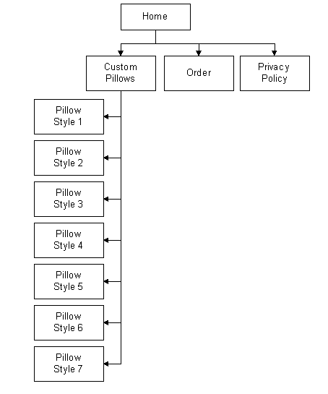
b. Just Throw Me
Student answers will vary. The site map at the left is a suggested solution.

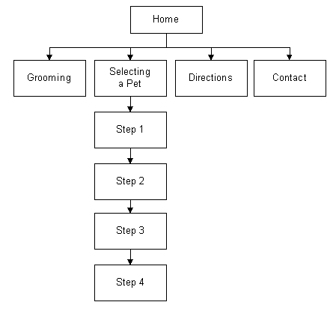
c. A Dogs Life
Student answers will vary. The site map at the left is a suggested solution.

3. Practice with page layouts.
a. Doug Kowalski, Nature Photographer
Student answers will vary. The page layouts below are a suggested solution.

Home Page: 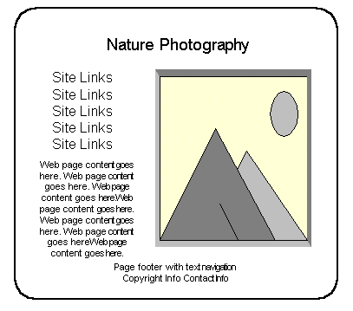 | Content Page:  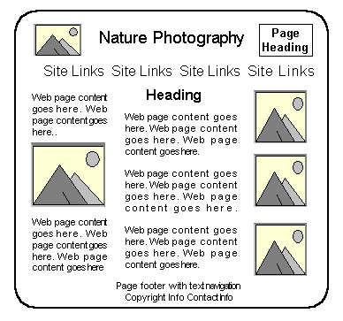

b. Just Throw Me
Student answers will vary. The page layouts below are a suggested solution.
Home Page:  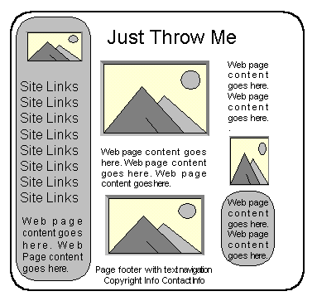 | Content Page: 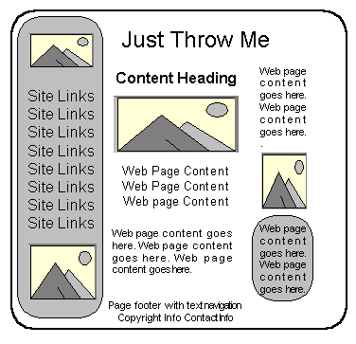

c. A Dogs Life
Student answers will vary. The page layouts below are a suggested solution.
Home Page & Content Pages:  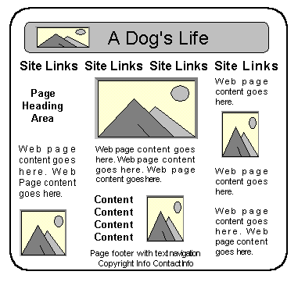 | Presentation Page: 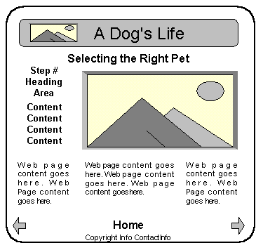

4. Student answers will vary.
5. Student answers will vary.
6. Student answers will vary.
7. Student answers will vary.
8. Student answers will vary.
Web Research
Your students’ answers should vary. Each student will write a one-page paper that describes five techniques for effective writing on the web. The URLs of the resources should be listed.
Focus on Web Design
1. Your students’ answers should vary. Each student should find two web sites that exhibit poor design practices. They will create a web page that documents their findings and provides the URLs of the poorly designed web sites.
2. Your students’ answers should vary. Each student should choose a web site to analyze and create a web page that presents answers to the following questions:
- What is the purpose of the site?
- Who is the intended audience?
- Do you believe the site reaches the intended audience?
- List three examples of how this web site uses recommended web design guidelines.
- How could this site be improved?

